SAP Application Development

(S/4 HANA)

Exception Handling

Content  This chapter is about Exception Handling. You will learn to define a class-based exception and how to raise and handle exceptions. | Prerequisites  You should be familiar with ABAP and principles of ABAP Objects and the navigation in the SAP system and Eclipse. Furthermore, you should have completed the Introduction to SAP Programming chapter.
Motivation  Exception Handling is an important technique in advanced ABAP programming.  Exceptions are necessary to make programs more robust, flexible and easy to use. | Lecture notes  Only students who finished module ABAP Objects are able to go through this chapter. This chapter builds upon the work from module ABAP Objects.  Students can go on with their account from previous exercises.

- Product: All

- Level: Advanced

- Focus: Programming

- Version: 2.0

- Author: UCC Technical University of Munich

Task 1: Login into the SAP system within Eclipse
Short description: Use Eclipse to login into the SAP system with your username and password
Login

Start Eclipse and select a local workspace where your ABAP project will be stored.

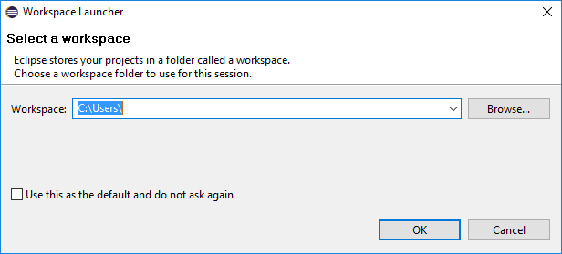

If you have already passed another learning module from this course, navigate to your project and login to the development system using your account from the previous chapters.

Elsewise create a new ABAP Project and Package according to the instructions in the chapters Introduction to SAP Programming and Development of a first program.

Task 2: Create a new exception Class
Short description: Use the ABAP Workbench to create class-based exceptions

In this chapter we will implement some exceptions for the configuration of flight data.

- The wrong type of airplane was selected.
- The maximum number of seats is reached for this type of airplane.
- A system exception occurred: reference to an object is initial.

For cases 1 and 2 the necessary classes have to be created. Since both exceptions refer to one airplane type, it is advisable to create a superclass and use inheritance.

Please start the SAP GUI from Eclipse by clicking the SAP GUI Icon in the Menu Bar:
Access to the Class Builder

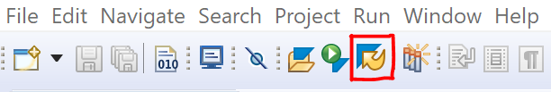

Choose your project and click OK. Navigate to the Class Builder using transaction code SE24.

Create exceptions

Create a new Class for the exception-superclass. The name is ZCX_$$_###_PLANETYPE.

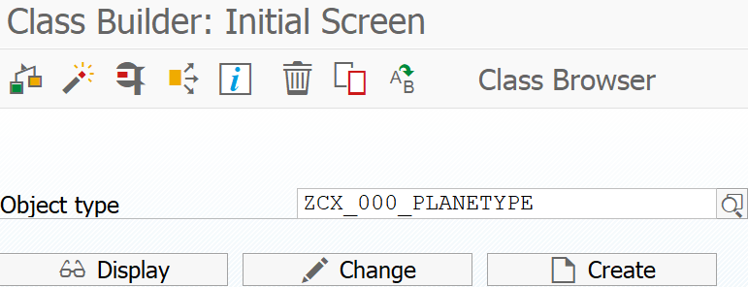

Select Exception Class as the Class Type. The Superclass should be set to CX_STATIC_CHECK and of type Public. Make sure not to mark the class as final and uncheck the “With Message Class” option of the exception class.

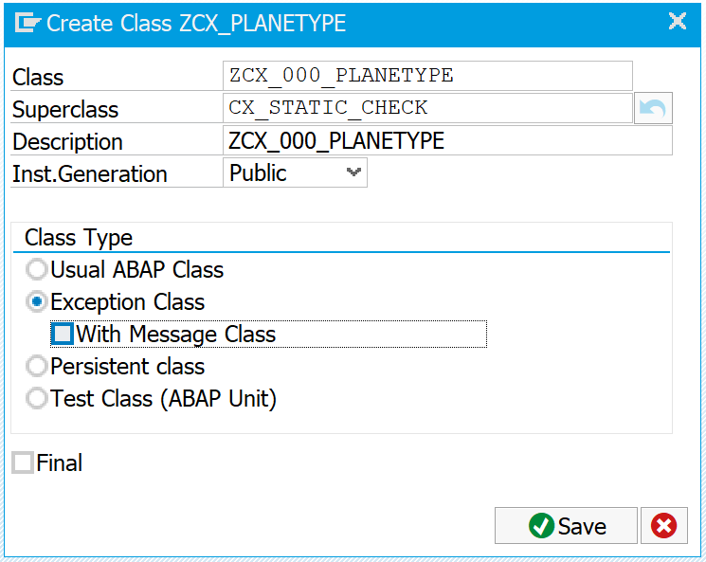

Save the class and add it to your package and transport as described in the exercise Development of a first program.

Exception Text
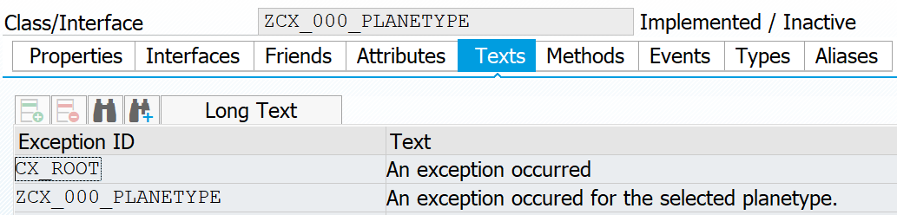

Change to the tab Texts. Type in a text for the newly created exception ID as shown in the screenshot.

Save your changes.
Wrong planetype - Exception

As the next step, please create an exception for the wrong plane type exception. Use the name ZCX_$$_###_WRONG_PLANETYPE and use the exception class created above as the Superclass. Mark the class as final.

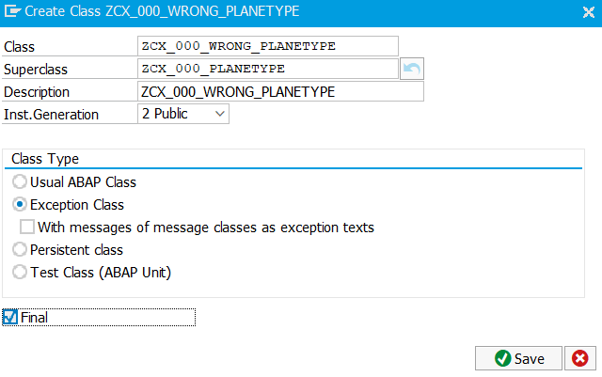

After saving the class change to the tab Attributes. Since we are interested in the planetype that caused the exception, add an attribute named planetype of type string to the exception attributes.

Important:

Save and activate after you have added the attribute PLANETYPE. You don't have to add the attribute of ZCX_XXX_WRONG_PLANETYPE! This is done automatically after saving and activating.

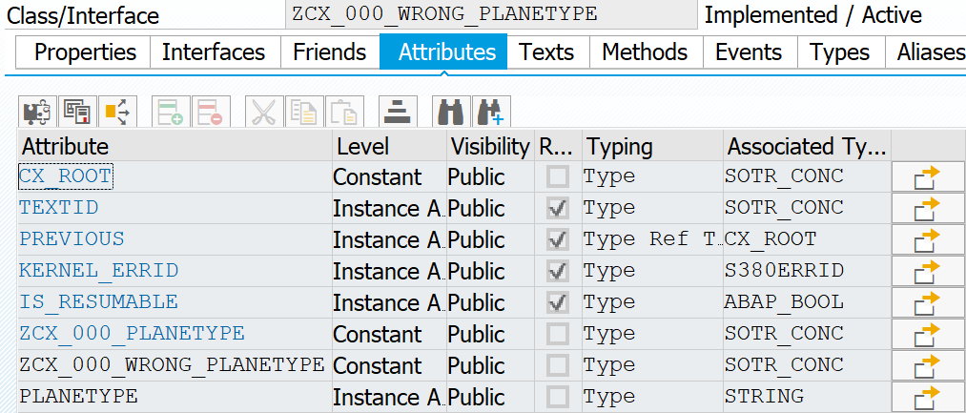

Important: After adding the attributes you have to save your exception class. Otherwise the attribute cannot be used in an exception text.

For the exception Text you are now able to reference the created attribute planetype. Change to the tab Texts. Type in the text

Plane type &planetype& does not exist.

At runtime, the placeholder is used to display the plane type that caused the exception to occur.

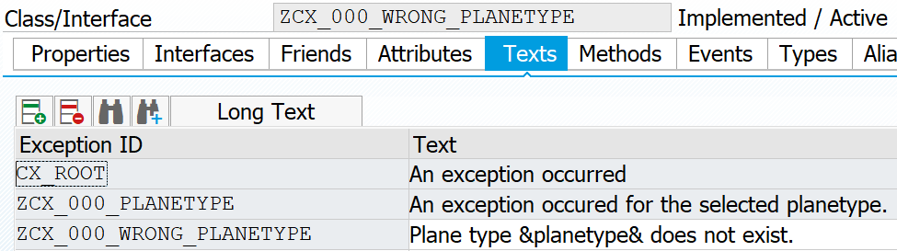

Repeat these steps for the other exception. This exception is called ZCX_$$_###_MAX_SEATS.

Maximum number of seats - Exception
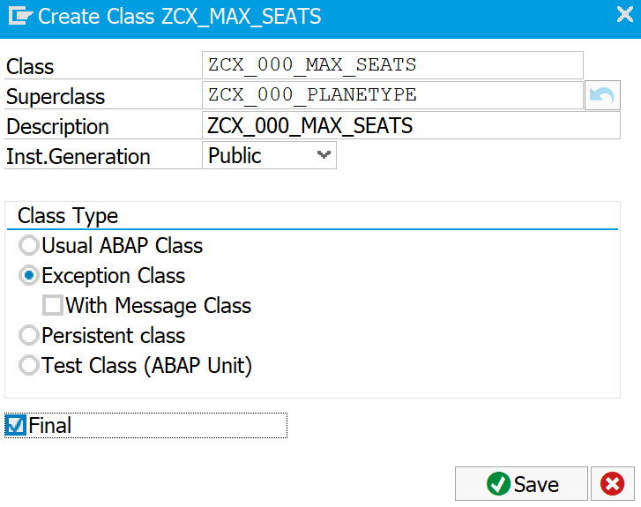

It has an additional public instance attribute called max_seats of Type I (Integer) to store the maximum number of seats which are available in the airplane. The exception text should be
Maximum number of available seats &max_seats& is reached. No more bookings possible.

Save and activate your changes.

Task 3: Create an ABAP report and learn how to raise and catch exceptions.
Short description: Create an ABAP report to raise the previously created exceptions.

If you have already done the exercise for Module ABAP Objects, you can copy your class ‘Z_$$_###_CLASS_INCLUDE’ to
‘Z_$$_###_CLASS_EXCEPTIONS _INCLUDE’ and modify the code for this exercise.

Create a new ABAP program ‘Z_$$_###_EXCEPTIONS’.
You will create a new local class with the purpose to represent airlines.
Create a new include program Z_$$_###_CLASS_EXCEPTIONS_INCLUDE.

The class should have the four private instance attributes gv_name (representing the flight name, e.g. Munich or Hamburg), gv_planetype (representing the planetype, e.g. Boeing 737 or Airbus 380), gv_max_seats, gv_occ_seats. For simplicity, set the default value of the maximum number of seats to 300 and the number of already occupied seats to 255.

Defining the used exceptions
Additionally, implement the following public instance methods: set_attributes with importing parameters im_name and im_planetype, get_attributes, check_planetype raising exception ‘ZCX_$$_###_WRONG_PLANETYPE’ and method add_seats raising exception ‘ZCX_$$_###_MAX_SEATS’. As both exceptions are derived from exception ‘ZCX_$$_###_PLANETYPE’, it is sufficient to specify this exception in the raising clause.

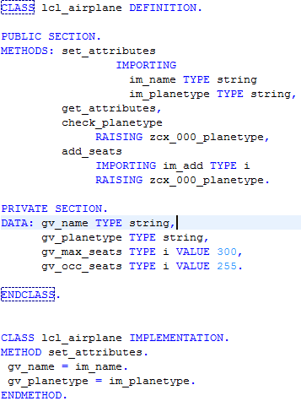

The implementation of method set_attributes should set global attributes gv_name and gv_planetype.
Method get_attributes should write these attributes plus – if it is below the number of available seats - the number of occupied seats gv_occ_seats to the output screen. Method check_planetype has to check whether the entered plane type is in the list of valid plane types (here ‘Boeing 737’and ‘Airbus 380’). Finally, method add_seats has to increase the number of occupied seats by the entered number. If the total number of occupied seats exceeds the maximum available number of seats, exception ZCX_$$_###_MAX_SEATS should be raised.

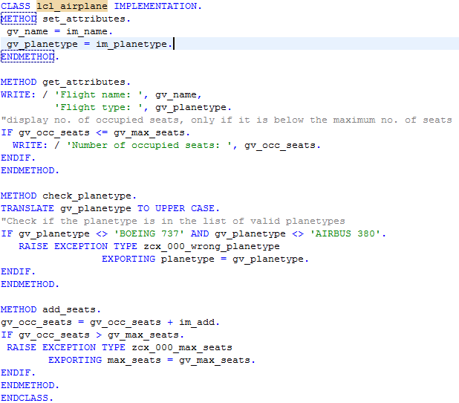

Change back to your ABAP program ‘Z_$$_###_EXCEPTIONS’ and call the just created include typing

We want to enable the dynamic input of parameters for our report. Therefore, we define the following input parameters:

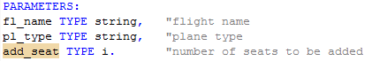

Advice: To change the selection texts (these are the field labels, which will be displayed on the output screen) of parameters in Eclipse, you have to do the following: Right-click on the parameter Open Others Text elements

Additionally, the following data declarations are needed:
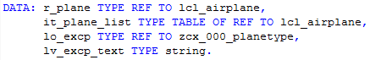

Now start the block ‘START-OF-SELECTION’. Create an object with command CREATE OBJECT that is referenced by variable r_plane. Call method set_attribute using this reference and assign name and plane type to the new object using the corresponding parameters of the method.

Advice: Use Shift + Enter for code completion

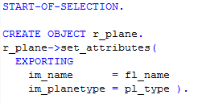

Now we want to find out, whether the entered plane type is in our list of valid plane types ‘Boeing 737’ and ‘Airbus 380’ by calling method check_planetype. As we have implemented the exception ZCX_$$_###_WRONG_PLANETYPE, we now have to catch the corresponding exception object.

Additionally, exception handling has to be implemented.
For this, you first have to check, whether the exception object was created. In case that the exception object is not initial, get the exception text and display it on the output screen.

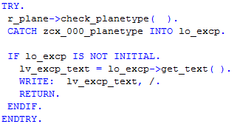

In a next step, we want to increase the number of occupied seats in the airplane by the number seat which was entered on the input screen. For this, you have to call method add_seat and implement an error handling in the same way as for method check_planetype.

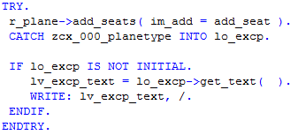

Finally, the attributes of the airplane should be displayed.

Finally, execute  your report after saving and activating your changes.

What happens, if you exceed the maximum number of seats? What happens if you enter a plane type which is not in the list of valid airplanes (Airbus 380, Boeing 737)?

Can you enter any random flight name?

Task 4
Short description: Raise and catch a system exception.

An error, that occurs frequently in ABAP Object programming is that the reference to an object is initial. The exception which is raised in this case is the system exception
CX_SY_REF_IS_INITIAL.

Try to call method set_attributes of class lcl_airplane in your report ‘Z_$$_###_EXCEPTIONS’ without having created an object r_plane as in the tasks before.

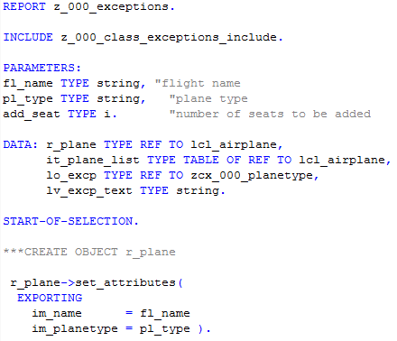

Save, activate and run the program.

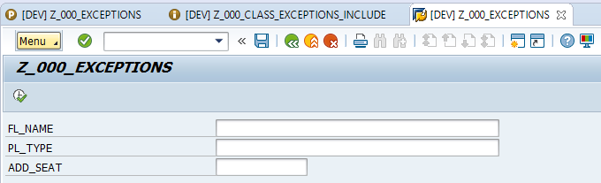

By clicking on the execute button, the following exception will occur:

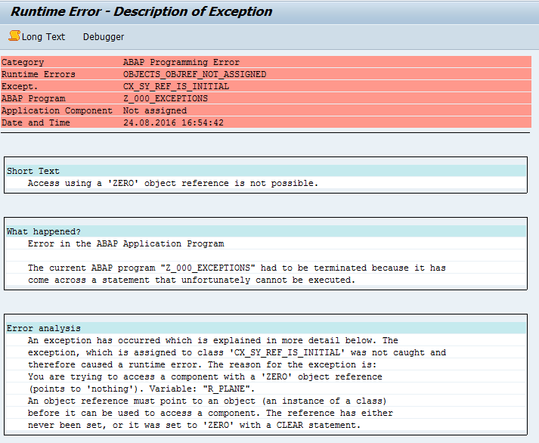

Now, catch the exception which is described in the runtime error above into an exception object.
Like every exception class, CX_SY_REF_IS_INITIAL is derived from a superclass, in this case it is CX_DYNAMIC_CHECK.

Enclose the exception within a try – catch – entry structure and write the longtext of the exception to the output screen and return.

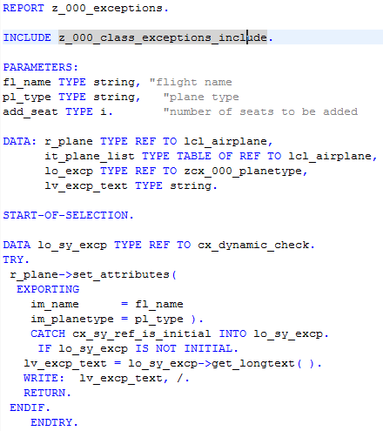

Save, activate and run your program and click on the execute button.



The output should be the following:

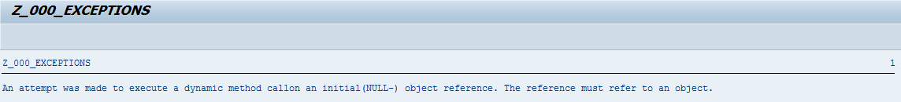

Challenge:
Short description: Extend your report and class with a check for the flight name. The flight name will be accepted if it is ‘Hamburg’ or ‘Munich’.

